EXTENSIBLE VISUALIZER
FOR ATOMIC FORCE MICROSCOPY

A thesis submitted to the University of Manchester for the degree of
Master of Science in the Faculty of Science and Engineering

2005

JONATHAN WALLER

DEPARTMENT OF COMPUTER SCIENCE

Contents
Contents 2
List of Figures 4
Abstract 5
Declaration 6
Copyright 6
Author 6
Chapter 1 - Introduction and Specification 8
1.1 General Statement of the Problem 8
1.2 Aims of Project 11
1.3 Key Terms – Some Basic Definitions. 11
1.4 Objectives 13
1.4.1 Primary Objectives of Project 13
1.4.2 Secondary Objectives of Project 13
1.4.3 Possible Expansion 14
1.5 External Review 14
1.5.1 Similar Projects 14
1.5.2 Interest to the Computing Community 16
Chapter 2 - Analysis and Design 17
2.1 Choice of 3D Renderer 17
2.1.1 Self-Designed Software Rendering Engine. 17
2.1.2 OpenGL 17
2.1.3 Direct3D (part of DirectX) 17
2.1.4 Java3D 18
2.1.5 MATLAB 18
2.1.6 VRML Viewer 18
2.1.7 Conclusion 18
2.2 Choice of Programming Language 19
2.2.1 MATLAB 19
2.2.2 C# 19
2.2.3 Java 19
2.2.4 Delphi 19
2.2.5 Conclusion 19
2.3 Application Structure - Choice of Classes 21
2.4 Classes in Application 23
Chapter 3 - Development and Implementation 28
3.1 Application Features 28
3.1.1 Filter Extensibility 28
3.1.2 Tool Extensibility: 30
3.1.3 3D Window 32
3.2 Data Structures Employed 34
3.2.1 Surface Topology 34
3.2.2 T3DModel 34
3.3 Data Inputs, Outputs and Formats 35
3.4 Use of Tools, Libraries and Existing Code 36
Chapter 4 - Summary 37
4.1 Source Code Length 37
4.2 Extent To Which The Aims Have Been Fulfilled 38
4.2.1 Primary Objectives of Project 38
4.2.2 Secondary Objectives of Project 39
4.2.2 Possible Expansion 42
4.3 Accomplishments 43
4.4 Conclusions and Future Work 44
References 45
Bibliography 49
Licensing and Copyright 52
Appendix 53
User Guides 53
User Guide 1 - Applying A Filter And Using Tools To Analyse The Output. 53
User Guide 2 - Using the Lennard-Jones Potential Filter 60
User Guide 3 - Creating a User-Defined Filter. 62
User Guide 4 - Creating a User-Defined Tool. 65

List of Figures
Figure 1. AFM Operation. 8
Figure 2. A Tip Traverses the Sample. 9
Figure 3. AFM Visualizer Internal Structure. 21
Figure 4. Default action for properties page display. Can be overridden by filters. 22
Figure 5. Structure of "Per-atom Lennard-Jones Potential" filter. 22
Figure 6. 3D surface showing probe and rectangle tools. 23
Figure 7. 3D window showing false colour surface and probe tool. 32
Figure 8. 3D view of convoluted surface. 33
Figure 9. 3D view of unconvoluted surface. 33
Figure 10. Initial application window. 53
Figure 11. DCT tip selection window. 54
Figure 12. DCT filter processing in progress. 55
Figure 13. DCT filtered image output. 55
Figure 14. Selection of tools being used on convoluted image. 56
Figure 15. ToolText's text properties window. 57
Figure 16. 3D surface without tools. 58
Figure 17. 3D surface with tools. 59
Figure 18. Graph of Lennard-Jones Potential function 60
Figure 19. Properties box of Lennard Jones Potential filter. 61

Abstract
Atomic Force Microscopy (AFM) is a method for measuring the topological displacement of a microscopic surface.
To create a displacement map of the surface, a cantilever with a very sharp tip is moved over the surface, while measuring the cantilever's vertical displacement. The surface position is adjusted horizontally to ensure the tip does not scratch through the material.
An important problem in AFM is that the tips are never perfect so the output image is subject to error and distortion. For reasons described in this document, the nature of the contact means that it is often impossible to remove this distortion. This makes surface analysis more difficult as researchers may be unsure whether the source of a particular surface feature is due to the underlying surface topology or a distortion due to an imperfect tip.
This work proposes and documents the development of an application that can be used to simulate the distortion effects caused by the interaction of the tip and the sample. This allows researchers to investigate a wide variety of tip-surface combinations to visually examine the kinds of distortion caused in order to derive the origin of the surface features. A selection of tools such as a probe and an area tool have been implemented to allow data extraction from the output surface, and new tools may be added easily to the application.
To aid the analysis process, a 3D representation of the output was added to the application, allowing a researcher to see the surface from an angle of their choosing. This surface can be analysed quantitatively with the application's extensible toolset.
With the successful completion of this application, it was extended to allow user-defined distortion filters to be added to the application, simulating any phenomena required. Not limited to AFM, this is of great use to other measurement systems subject to distortion effects such as optical or magnetic microscopy.

Declaration
No portion of the work referred to in the thesis has been submitted in support of an application for another degree or qualification of this or any other university or other institute of learning.

Copyright

(1) Copyright in text of this thesis rests with the Author. Copies (by any process) either in full, or of extracts, may be made only in accordance with instructions given by the Author and lodged in the John Rylands University Library of Manchester. Details may be obtained from the Librarian. This page must form part of any such copies made. Further copies (by any process) of copies made in accordance with such instructions may not be made without the permission (in writing) of the Author.

(2) The ownership of any intellectual property rights which may be described in this thesis is vested in the University of Manchester, subject to any prior agreement to the contrary, and may not be made available for user by third parties without the written permission of the University, which will prescribe the terms and conditions of any such agreement.

(3) Further information on the conditions under which disclosures and exploitation may take places is available from the Head of the School of Computer Science.

Author
Jonathan Waller graduated from The University of Reading in 2004, achieving a BSc in Computer Science with an emphasis on visualisation and distributed systems. He is studying towards an MSc in Advanced Computer Science with ICT Management.
Acknowledgements

I would like to express my appreciation to my supervisor Dr E. Hill. I was very grateful for his guidance throughout this project.

I would also like to express my gratitude to my family and friends, especially Noel Evans, Hiroshi Suemitsu, and Dale Williamson, who provided motivation and support.

This project was produced under funding from the Engineering and Physical Sciences Research Council.

Chapter 1 - Introduction and Specification

1.1 General Statement of the Problem

Atomic Force Microscopy (AFM) is used for the visualisation of very small objects. With high resolutions provided by sharp tip geometries, this may even reach atomic resolution. [4, 5]

AFM works by slowly passing the point of a cantilever over a sample, adjusting the sample’s height so that the same force acts upon the cantilever. By bouncing a laser off the top of the cantilever the movement can be measured. [2] See Figure 1.

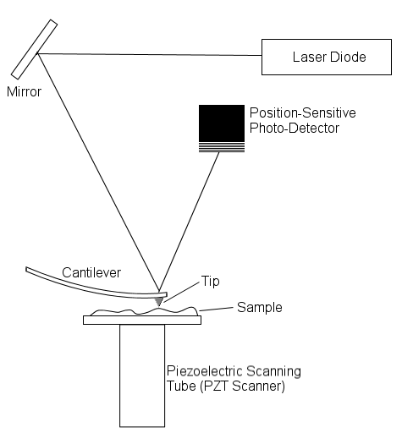
Figure 1. AFM Operation.

“Unlike traditional microscopes, scanned-probe systems do not use lenses, so the size of the probe rather than diffraction effects generally limit their resolution.” (Baselt 1993) [7]

It is of great importance that the tip is sharp, as a blunt or distorted tip head will cause distortion in the image. This effect is shown in Figure 2. A usual method of measurement is “non-contact mode” meaning that the tip will not touch the surface, but the surface will be moved to keep the cantilever at a set displacement. [9] The surface and tip weakly attract each other due to the Van der Waals forces between the atoms of the surface and the atoms of the tip. [8]

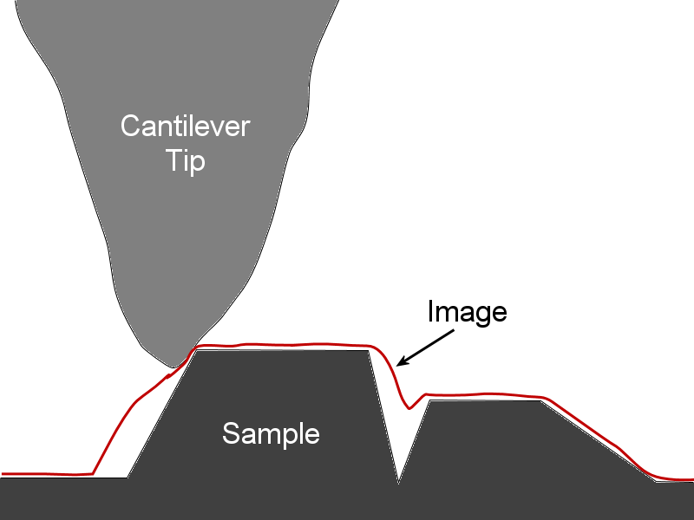
Figure 2. A Tip Traverses the Sample.
Discrepancy between measured and actual surface are shown.

When an image is generated by AFM with a poor tip, the image will be distorted.
"Eliminating tip effects is, well, tricky. I would like to say impossible, but that would be the end to much of my research. Distortion due to tip effects in SPM can be split into three: geometric effects, point-spread effects, and interaction effects.” [3]
Phil Williams (School of Pharmaceutical Sciences, Univ. of Nottingham).

- Geometric effects regard how the moving tip profiles and follows the physical shape of the surface.[2] A distortion will occur, for example, when the apex of the tip does not touch the surface of the material because another part of the tip is in contact with the surface. This means a correct image of the surface contours cannot be obtained regardless of further image processing.[10]
- Point spread. The interaction of the Van der Waals force does not occur just in a vertical direction from the tip apex to the surface below it, but from each atom in the tip to each atom in the surface. If the atoms are far from each other then the attraction is very slight, but close atoms experience a much larger force. This distortion is very similar to a standard blur and can largely removed by using algorithms such as Maximum Likelihood, Weiner inverse filtering, and Jansson van Cittert. [3]
- Interaction effects
Sample-tip interaction effects can be “very large, or very small, and almost impossible to predict, measure, and account for” [3]. Using sharper tips to compensate for geometric distortions often means the tip is more susceptible to interaction distortions.

This distortion means that if an image from a microscope contains a feature, one sometimes cannot be sure whether this feature is due to a distortion caused by the tip or an underlying part of the surface topology [10].

Because it is often difficult (or impossible) to recover the original surface profile from the distorted image output from the microscope, another approach was needed.

Although it is difficult to remove this distortion, the geometric and point spread distortion can be simulated and added to an undistorted surface. A researcher may choose a tip shape, and try different potentially correct surfaces to compare with real microscope output. In this way, a researcher will be able to ascertain how each tip and surface interacts and which surface and tip combinations will generate a distorted surface that matches the distorted microscope output. [11]

1.2 Aims of Project
This document describes the design and implementation of an application to simulate tip-surface distortion in AFM. By taking a tip and surface topology, one may generate a distorted surface such as would be output from an atomic force microscope.

Through this application the aim of this project was to create a framework for comparing simulated output of various AFM effects. There was a need to make it extensible so that new filters could be added to the system by researchers. The framework needed to be flexible enough to allow any kind of surface manipulation to be applied.

This application is targeted towards researchers in the field of AFM, however the generic filtering interface in the program can be used to allow many filters to be created, not necessarily related to tip distortion in AFM.

From inception, this project had two main aims. The first was to create a program which could apply distortion effects to a surface to see how different shaped tips would affect the output from an atomic force microscope, and second, to create an easily extensible program so filters could be created for a much larger number of tips, and other effects as deemed relevant by researchers. Different kinds of distortion filters would be useful as distortion occurs in other microscopy fields such as magnetic or optical imaging, and an application such as this would be very useful to visualise and analyse these effects.

1.3 Key Terms – Some Basic Definitions.

Tip
The refined pointed end to the cantilever in an AFM device. Usually made of silicon or silicon nitride [12], the quality of this tip is of primary concern to the production of a distortion free image.

Surface
The surface refers to the topological shape of the sample being visualised and modified.

AFM
Atomic Force Microscopy (AFM) is used for the visualisation of very small objects. With high resolutions of tip, this may even reach atomic resolution [2].
AFM works by slowly passing the point of a cantilever over a sample, adjusting its height so that the same force acts upon the cantilever. By bouncing a laser off the top of the cantilever the vertical displacement can be measured. [12]

Convolution
Convolution is used to create a surface such as would be output from an AFM. This takes an ideal surface, and uses a tip to create an output surface that would be generated by combining that perfect surface and a (possibly imperfect) tip.
Convolution is defined as the integral of the product of the two functions after one is reversed and shifted. [13] In this application, convolution is not performed on functions, but discretely on data values of a surface. The integration range is the width (or height) of the surface fragment under the tip.
For discrete one-dimensional functions, convolution is given by:
$(f∗g)(m)=\sum_{0}^{n}{(f(n)∗g(m−n))}$
Within this program convolution is performed in two dimensions on the frequency domain versions of the surface fragment and tip. Performing the convolution in the frequency domain will return the frequency response between the surface and tip, and once converted back into the space domain, aims to be an approximation of the distortion effect of passing the tip over that surface fragment. This can be explained by realising that a surface containing only low frequency components will appear smooth with long curves, and a surface with only high frequencies will be flat but highly pitted and detailed. The product of a convolution in the frequency domain of a highly detailed surface with a large smooth tip will be a surface containing only the low frequency components of the input surface, without the high-frequency, detailed, surface information. This mirrors the real-life situation where a large coarse tip will miss the high frequency aspects of a surface profile. [11]

Deconvolution
Deconvolution is the process of taking a distorted surface as output from AFM and attempting to remove effects caused by convolution. Because the convolution function is equivalent to dilation, data is lost, so deconvolution can only be performed to within a confidence level. This is (mathematically) why direct deconvolution to a correct surface is impossible.

1.4 Objectives
Through discussions with Dr Hill, a vision for the application was created. The required, optional and future features for the program were chosen. These are listed below:

1.4.1 Primary Objectives of Project
The following objectives were deemed to be essential to the project:
- Allow import from the HDF [32] format.
- Allow import of pre-generated “perfect” datasets.
- Display 2D representations of inputted datasets.
- Perform convolution on the “perfect” datasets to create distortion. This convolution would be based on data known about the tip.
- Display a 3D representation of real data and post-convoluted data.
- Allow users to rotate a 3D representation with their mouse.
- Allow input of data about many different tip types, thus affecting the convolution effect.

1.4.2 Secondary Objectives of Project
The following objectives were deemed useful and should be implemented if time allowed:
- Allow image export from 2D and 3D displays.
- Allow change to the colour map, so that height change in 2D and 3D representations would be easier to discern.
- Attempt to de-convolute the real data given about the tip properties. This may be only possible to a particular level of confidence as tip shape may be irregular.
- Add measurement tools such as point-to-point and volume calculation.
- Allow comparison of real and post-convoluted “perfect” data. This could be done either visually or by performing mathematical subtraction between the surfaces.
- Allow image output in a variety of image formats.
- Allow 3D model output from the 3D display.
- Add a feature for the program to generate its own perfect datasets, with guidance from the user.
- Allow choice of many material properties. This would change the convolution effect of the perfect data.
- Allow choice between Fourier Transform based convolution, or the slower but more accurate per-atom method.

1.4.3 Possible Expansion
The following objectives were deemed to be impossible to complete in the given time, but would be nice features to have. If the application were to be expanded, these features would be desirable:
- Add more analysis techniques. Such as cropping of dataset or cut planes.
- Integration with commercial hardware.

1.5 External Review

1.5.1 Similar Projects
There are several programs, commercial and free, that incorporate some aspects of the designed application. A brief comparison of these applications and the AFM visualizer is performed below:

MIDAS Deconvolution Software [15]
This software used to perform convolution and confidence-based de-convolution of surfaces. However, it lacks a 3D display, analysis tools and may only perform one form of convolution.

Deconvo – Deconvolution program. [16]
Deconvo performs deconvolution of surfaces and generates certainty maps of surface and tip interaction. Like MIDAS it lacks analysis tools and a 3D output.

Scanning Probe Image Processor, SPIP [17]
This application is a modular image processing tool for nano-scale datasets.
It can be extended to perform many types of image and surface convolution, but does not include a facility for analysis or 3D display.

Statscan [18]
This program does not strictly belong here as it is a SPM height calibration program, and not used for surface convolution. However it has extensive 2D visualisation features used for SPM.

WSxM Scanning Probe Microscopy Software [19]
This software is released free and has features for dataset visualisation. It also includes a facility to control an external microscope.

MS MacroSystem - 3D Surface View Software [20]
This program creates detailed visualisations, and can be used to perform analysis such as slices or boxes of the data set. Although it can be used for AFM visualisation, it does not have any features targeted towards AFM.

AFM Visualizer, the application developed here, adds many of these features together. It combines the extensibility of SPIP, the standard convolution operation of MIDAS and allows for 3D visualisation, as found in MS MacroSystem. Beyond the other applications, AFM Visualizer also allows for analysis tools to be created and added to the application easily, and visualised in both 2D and 3D. The only features mentioned above that AFM Visualizer lacks is external microscope control and a de-convolution algorithm.

1.5.2 Interest to the Computing Community
As AFM technology has improved, the problem of poor tip quality affecting the clarity of an output image has become more relevant. [14] This application will not remove surface distortion but is a powerful tool for finding where distortion occurs.
It will be of great use to researchers in the field of AFM, and due to its extensible nature, it could be of great use to researchers in other fields that deal with image or dataset distortion.

Chapter 2 - Analysis and Design

2.1 Choice of 3D Renderer
For implementing 3D graphics within this application, a selection of approaches were considered. The first consideration was whether to create a software-based rendering engine or to use a 3rd party API, such as OpenGL or DirectX. The choice of which rendering engine and programming language to use are linked; because for example, you cannot use Direct3D in Java.

2.1.1 Self-Designed Software Rendering Engine.
Writing one's own renderer has the advantage of direct and precise control over polygons, lighting and output. All possible features deemed necessary for the application could be implemented given enough time, with no restriction to number of features that could be implemented. (For example, OpenGL does not support radiosity [31], but a self-made renderer could.)
There are large dataset sizes involved so hardware acceleration is a requirement. A standard implementation would not take advantage of hardware acceleration. To use hardware acceleration within an entirely user-developed API, one must write a device driver to interface with the graphics card. This seems to an unnecessary amount of work when all the features needed exist in third party APIs.

2.1.2 OpenGL
OpenGL [21] may be accessed from programs written in C, C++ and C#. One may also access it though Java with the third party library "GL4Java" [34].
OpenGL allows hardware acceleration, which is of great importance for visualising datasets of this size. It has direct support for lighting, polygon shapes, materials and transparency. OpenGL is widely supported on many architectures, both Windows Solaris and Linux.

2.1.3 Direct3D (part of DirectX)
Direct3D[22] may be accessed from programs written in C, C++ and C# as well as Visual Basic, but the author knows of no way of rendering in Direct3D through Java. Direct3D it is restricted to Windows systems. Direct3D supports hardware acceleration, and a wide variety of graphical effects such as reflection, environment mapping, and higher end features such as “Pixel Shaders” [23].

2.1.4 Java3D
Java3D [24] is a 3D graphics library packaged with more recent versions of Sun's Java. It doesn't allow for hardware acceleration.

2.1.5 MATLAB
MATLAB [25] has good (if slow) graphing facilities. It doesn't allow freeform 3D objects to be created, and the author was unsure if visual feedback from the tools could be reflected within a MATLAB visualisation.

2.1.6 VRML Viewer
VRML [26] is a model format, usually used for displaying 3D environments across the Internet. To view VRML, one must download a viewer for the file. A VRML viewer has a reasonable speed when displaying high detail objects, but has no real-time feedback unless scripting is employed. It would be ideal for demonstrating surface topologies across the Internet, but not ideal for real-time feedback or reading quantitative output from tools.

2.1.7 Conclusion
Both Direct3D and OpenGL allow hardware acceleration, which is required for an output of so many triangles. A VRML viewer would be quick enough, but lacks the real-time feedback required. Both Direct3D and OpenGL have libraries to control colours, lighting and 3D transformations.
The author had used OpenGL before, so knew what could be created with it quickly.
The focus of the project was on AFM distortion and 3D graphics was an added feature. As production of this application was in a tight timeframe it was decided not to learn the completely new graphical API, Direct3D, but to focus on the remaining option; OpenGL.

2.2 Choice of Programming Language
A range of programming frameworks were considered for use in creating this project; ranging from a pure programming language to building the application within MATLAB, a mathematical tool. Here are the conclusions:

2.2.1 MATLAB
MATLAB is ideal for performing mathematical operations such as the Fourier Transform, and has a wide variety of mathematical facilities that can be called upon. MATLAB allows a user to create a user interface and can load data from files.

2.2.2 C#
C#, a language of the ".NET" framework, is compiled to CLI, a common language not unlike Java's byte-code [27]. Programs written in .NET languages used to be restricted to Windows based systems, but with the advent of the open-source project "Mono" .NET programs can run on other architectures too [28]. C# has a large class library and allows for quick prototyping.

2.2.3 Java
Java [29] aims to be a platform independent language where one program is compiled to "byte-code", and then run on a virtual machine. It too has a large class library, and is ideal for quick prototyping and multiplatform development.

2.2.4 Delphi
Delphi [30] does support OpenGL, but the author has found OpenGL applications in Delphi are vastly underpowered and lack the desired responsiveness when displaying high polygon count objects such as a large surface dataset.

2.2.5 Conclusion
Approaching this project as a learning experience, the author did not want to rely on MATLAB's "black box" to perform operations such as convolution and the Discrete Cosine Transformation, but wanted to implement them himself. It was also believed that using OpenGL commands directly from an application would allow accurate control over visual output; control that would be lacking if one were to rely on MATLAB's inbuilt renderer to convert surface values to their 3D representation. For these reasons Java and C# were chosen over MATLAB. While the author had created his undergraduate project in Java, he had not used C# extensively so chose to use this language to increase his experience with it.

Looking at these advantages and disadvantages, it was decided to use OpenGL with C#.
.NET applications, such as those written in C#, usually only run on Windows systems. However, the open-source project “Mono”, sponsored by Novell, allows .NET applications to run on Linux, Solaris, MacOS X, and UNIX systems [28]. OpenGL also runs on a wide variety of system architectures including Solaris, Linux and Windows. This is unlike Direct3D, which is limited to Windows.
Using this combination of OpenGL and C# is ideal as the application is not limited to a single platform, and allows for quick prototyping of new features. By using the quick prototyping methodology with OpenGL, high-quality hardware accelerated 3D graphics can be implemented quickly.

2.3 Application Structure - Choice of Classes

Figure 3 shows the internal structure of the AFM visualizer. The main form ties the filters, tools and 3D window together. Once a surface is created and populated with data, it is passed to the filter chosen by the user, and then to each tool as needed. The processed surface is also passed to the 3D window, FormOpenGL, and then rendered to the screen by the OpenGL class “Surface3DView”.

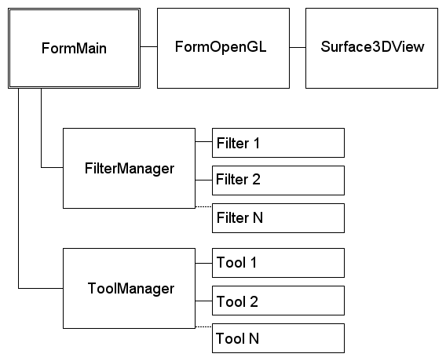
Figure 3. AFM Visualizer Internal Structure.

FilterManager and ToolManager are used to provide a single interface to the filters and tools respectively. Abstracting the filter or tool interface in this way means that the application can use each filter or tool in the same way, regardless of that module’s function. By providing a consistent interface to the tools or to the filters, and a facility to collate the tools or filters in one place, allows easy modification to the list of filters or tools that the application supports. For example, to connect a new filter to the application, just one line must be added to the array of filters within FilterManager.
The “surface” object is key to this application. It is used to store both a 2D and 3D representation of a surface, as well as providing facilities to modify the data set and convert the surface to the frequency domain. The surface object is passed around the application. When the surface is to be filtered, it is passed to the filter and the filter returns a modified surface. The surface also contains a 3D shape, usually a topological model of the surface, which can be rendered through the 3D window.

Tools and filters are responsible for generating their own properties boxes and warning messages. Any optional features have default actions, which can be overridden if a tool or filter wishes to use them. “Properties pages” are an optional feature of filters, if a filter does not require user input from a properties page, the base class’s function will inform the user there are no properties that can be changed.

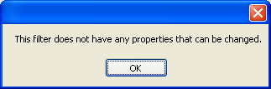
Figure 4. Default action for properties page display. Can be overridden by filters.

Filters or tools requiring features beyond those provided by the abstract class or helper classes such as “LJPotential” must implement them individually, and ensure program flow is still maintained.

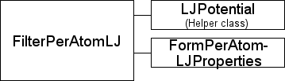
Figure 5. Structure of "Per-atom Lennard-Jones Potential" filter.

Figure 5 shows the internal structure of the LJ Potential filter. The class “LJPotential” provides functions used when calculating the Lennard-Jones Potential [35], and helps to simplify the code within FilerPerAtomLJ. Filtered surface data is used to generate a 3D surface which is stored within FilterPerAtomLJ.

The abstract tool class was becoming increasingly complicated, so to create an easy-to-understand base for future classes, the sections storing the tool’s 3D representation were extracted and contained within a new class, T3DModel. When the 3D window is viewed, each tool’s 3D model (T3DModel) is read by the OpenGL rendering thread, and combined with the filtered surface. This combination in 3D of tool and surface is shown in figure 6.
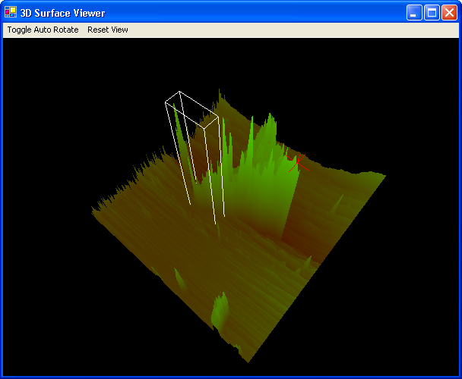
Figure 6. 3D surface showing probe and rectangle tools.

2.4 Classes in Application
Filter
A base class for all filters. Exposes an interface which can be implemented by new filters. This allows new filters to be accessed in a consistent way.

Filter50Percent
This is a simple filter which takes the input surface and scales it to 50% of its original size. This is to demonstrate that input and output data set sizes do not need to be equal.

Filter90Rotate
This is a simple filter which takes the input surface and rotates it 90 degrees around its centre in an anti-clockwise direction. This filter is an operation on the image portion of the inputted surface only and shows that the image and data parts of an input surface can be processed independently.

FilterBlue
This is a filter which takes the image part of an input section, calculates the greyscale image representation of the surface and outputs this new image shaded in blue. This is to show that the image and data parts of the input surface can be individually processed.

FilterBlur
This filter applies a simple 9x9 pixel blur to the surface dataset and recalculates a false colour surface image to be output.

FilterDCT
This filter performs a block-based Discrete Cosine Transform convolution on the input dataset and an inputted tip shape. The operation of this filter is explained elsewhere.

FilterNoChange
This filter performs no change on the input surface and outputs the same surface that was input. This is used when a researcher wants to use tools on the original data set, for debugging purposes and as a base for new filters to be created.

FilterPerAtomLJ
This filter performs a per-atom Lennard-Jones potential [35] convolution on the tip and the input surface using given values for the well depth and hard sphere radius (atom radius) collected from the LJ potential properties page. This will output an accurate representation of the deformation caused by the interaction of the tip and surface. The operation of this filter is described elsewhere.

FilterVerticalFlip
This is a simple filter that mirrors the surface data in the horizontal axis. The false-colour output image is recalculated and output.

FManager
FManager manages all the filters and allows the application access all filters in a common way, to count the number of active filters and to populate the filters ComboBox on the user interface with a list of active filter names.

FormMain
FormMain holds all the top-level user interface elements such as the input and output image boxes and the selection of active tools. This form contains a button which will show the 3D window.

FormDCTProperties
This form allows the user to choose a tip shape to be used with the DCT filter. They may choose from a section of predefined tips, or make their own in an image editing program and import it.

FormPerAtomLJProperties
This form allows the user to choose a tip to be used by the per-atom Lennard-Jones Potential convolution filter. It also allows the user to choose values for the well depth energy and the hard sphere radius, parameters for the LJ Potential function. [35]

LJPotential
The LJPotential class is a collection of functions used for convoluting a surface and tip using the LJ potential. It is not used directly, but called from the FilterLJPotential class.

Surface
This class holds topological and image data for a surface, and contains functions to convert the surface data to and from the frequency domain.

The following classes are from Fahey’s C# OpenGL wrapper [33], and wrap the OpenGL functions in a form that can be accessed by C#. They are used unchanged.
wglav5_gdi - Wraps OpenGL’s GDI functions.
wglav5_gl - Wraps OpenGL’s GL functions.
wglav5_glu - Wraps OpenGL’s GLU functions.
wglav5_user - Wraps OpenGL’s User functions.
wglav5_wgl - Wraps OpenGL’s WGL functions.

FormOpenGL
This form allows arbitrary 3D objects to be displayed. These objects can be rotated automatically or by the mouse. The usual choice of object to display is a relief map of the surface dataset, with different colours indicating the various heights

wglav5_surface3DView
This class takes 3D data from a surface, combines it with each active tool’s 3D data and draws it to the OpenGL window. It is based in part on wglav5_demo provided by Fahey’s C# OpenGL wrapper. [33]

TManager
This class manages the tools, used to analyse the output from the various filters. It contains functions to fill the tools ComboBox and to allow access to the tools individually. By using this class, all tools can be accessed in a consistent way, and the tool selection can be changed by just modifying one array.

Tool
This is the abstract base class of all tools. Its interface contains a function to return the tool’s name and functions to take mouse input from the output image surface.

ToolText
This class allows a user to place text on the output image, move it around, and choose its text content font and colour. Text can be written using Unicode, allowing annotation in the vast majority of all world languages.

FormTextChange
This form allows the user to choose a new font, colour, and text content for an annotation.

ToolProbe
This class implements a probe tool which may be dragged around the output image. It extracts the values from a particular point on the surface and displays them in the info window.

ToolScanLineBox
This class implements a rotateable draggable box tool which can select an area of data on the output image. It contains a ScanLine, which may be lay along a boundary line. The data extracted from this tool is shown in the info window.

ToolRectangle
This class implements a different kind of draggable box tool which can select an area of data on the output image. The data extracted from this tool is shown in the info window.

T3DModel
This class holds data representing a 3D model, it is used to store the 3D representation of tools. This data is stored in vertex arrays and so can be inputted directly into OpenGL and hardware accelerated.

Chapter 3 - Development and Implementation

3.1 Application Features

3.1.1 Filter Extensibility
This program allows two types of almost "plug-in" extensibility. Developers may create new filters or analysis tools to be used in the program. All created filters inherit from an abstract class, Filter. By inheriting from a known class, the filter interfaces can be made identical and new filter classes can be created. A developer adds their new filter to the FManager (Filter Manager) class and it will be added to the drop down list of available filters. The implementation of run-time plugins using DLLs with a specified interface was decided against as this makes debugging harder. Also plugin DLLs are often used when application developers do not want plugin developers to see the application code, but the source code of this application will be available to all.
A developer of a filter class has a lot of flexibility. The filter must return its own name and an output surface, but this output does not have to resemble, (or even refer to) the input surface. The input surface is an object that wraps all the parameters of the surface; it contains a table of data points, both raw and scaled from 0 to 1, minimum and maximum values, and a false-colour image representation of the surface. It also contains a data structure to hold arbitrary 3D data. This structure can be written to by the user-created filter to allow arbitrary 3D output to the 3D window. A selection of helper functions are included for standard display of normal-calculated coloured terrain data, or a developer may disregard this and create whatever 3D output they choose.
If the filter requires data items to be available before it can begin, it can inform the rest of the application that it cannot run yet, and can be queried for a text string to be sent to the user specifying what items are needed. An example of this is the DCT function needing a surface and tip to be selected before it can begin, or the per-atom LJ potential requiring these items as well as the values of epsilon (well energy) and sigma (hard-sphere radius). [35]
Because the input file does not specify world-space dimensions, if a filter requires these measurements it must acquire them another way, (by asking the user or reading from another data file, for example). The filter class can extend the showProperties function, allowing a user to specify options used by the filter.
The optional functions of canRun, getWhyCannotRun and showProperties are overridden if they are used, and implemented in the base class so if a class does not need to extend a function, the base class exposes the default functionality.
Controlling the progress bar is the responsibility of the filter class, but if a progress bar is not required, then this can be ignored.
The Filter abstract class is shown below:

public abstract class Filter
{
public ProgressBar progressBar;

//Returns the name of the filter. Must be implemented by all //filters.
public abstract String getName();

//Applies the filter to the surface. Must be implemented by all //filters.
public abstract Surface apply(Surface surface);

//Returns a boolean specifying if this filter can run,
//For example, running a convolution of a surface and a tip //when no tip has been selected will fail,
//so this function will return 'false' to stop the user //proceeding before they have chosen a tip.
public virtual bool canRun() {return true;}

//This is only called in filters where 'false' can be returned //by canRun
//If your filter only returns true, then don't implement this //function
public virtual String getWhyCannotRun() {return "";}

//Allows user to set filter properties.
//If there are no setable properties on your filter, don't //implement this function
public virtual void showProperties()
{
MessageBox.Show("This filter does not have any properties that can be changed.");
}
}

3.1.2 Tool Extensibility:
The tools used to analyse the data set may also be extended. Because the output from a user-designed filter can be very varied, the Tool abstract class is quite flexible to allow these outputs to be analysed.
The user input to all the tools is in the form of mouse movements and clicks. The tool generates visual output that is applied to the top of the output image from the filter. In the standard case the filter's output would be the image of the surface from above, with colours to indicate the heights at each point on the surface. The user would select a tool such as ToolProbe (to select a point) or ToolRectangle (to select a rectangular area), and then drag this tool around the output image to select the data to analyse.
However the tool image output is very flexible, one may use it to display a graph or arbitrary graphics. One could display and rotate 3D graphics on it too, but this would be easier through the 3D viewer where this facility is already set up.
The tool may also populate a 3D model object to create output in the 3D window. For example, when a surface is output from a filter, the 3D probe tool creates a 2D red cross on the 2D viewer and 3-axis 3D cross in the 3D window.
The tool may also return some textual data to the user with the getInfo function, if this is deemed more convenient than by the 2D graphical view. The probe tool uses this function to return information about the data point under the probe.
Also, in the same way as the Filter class, the tools abstract class allows a properties box to be displayed to get information from the user. For example, in ToolText, this is used to allow the user to change the font, colour and content of the text displayed on the tool window.
The tool abstract class is shown below:

public abstract class Tool
{
//Needed by some filters to look at data - accessed by //implemented tools such as ToolProbe.
protected Surface surface;
public T3DModel tool3D = new T3DModel();

//Returns the name of the tool. Must be implemented by all //tools.
public abstract String getName();

//Applies visual feedback from the tool to the image. Must be //implemented by all tools.
public abstract Image applyGraphic(Image image);

public abstract String getInfo();

//Mouse functions. Use these if your tool uses the mouse.
public virtual void mouseUp(object sender, System.Windows.Forms.MouseEventArgs e){}

public virtual void mouseDown(object sender, System.Windows.Forms.MouseEventArgs e){}

public virtual void mouseMove(object sender, System.Windows.Forms.MouseEventArgs e){}

public virtual void click(object sender,
System.EventArgs e){}

//Allows user to set tool properties.
//If there are no setable properties on your tool, don't //implement this function
public virtual void showProperties()
{
MessageBox.Show("This tool does not have any properties that can be changed.");
}

//Base class function. Don't implement this.
public void setSurface(Surface lSurface){surface=lSurface;}

//Helper functions
protected Point addVector(Point a,Point b){return new Point(a.X+b.X,a.Y+b.Y);}

protected Point subVector(Point a,Point b){return new Point(a.X-b.X,a.Y-b.Y);}

protected double vectorLength(Point a){return Math.Sqrt(Math.Pow(a.X,2)+Math.Pow(a.Y,2));}

protected double vectorLength(Point a,Point b){return vectorLength(new Point(b.X-a.X,b.Y-a.Y));}

void calcFaceNormals(){&lt;function cut&gt;}
void calcFaceNormal(int faceNum) {&lt;function cut&gt;}
}

3.1.3 3D Window
The surface can be shown in 3D though the use of the 3D window. The object displayed in this window is generated by the filter in use, and can be any 3D shape, not just a 3D relief map of a surface.
Also, the 3D representation of tools can be shown within the 3D window. Figure 7 shows the probe tool in use.

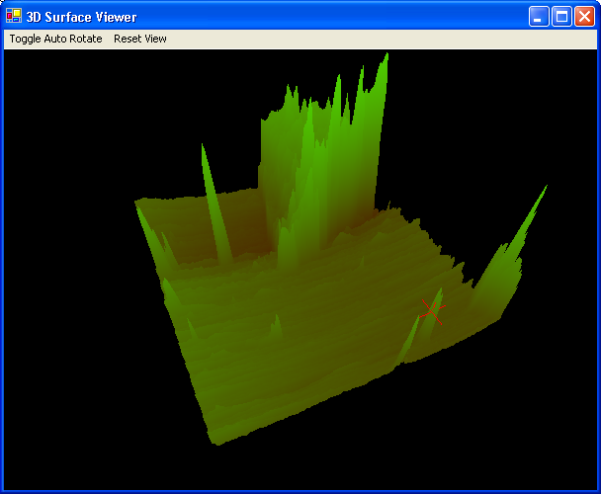
Figure 7. 3D window showing false colour surface and probe tool.

The output from the 3D window is a false colour representation of the filtered surface. Figure 8 shows a surface after filtering with FilterDCT, which performs a pseudo-blurring effect based on the frequency domain convolution of the tip and sections of the surface.

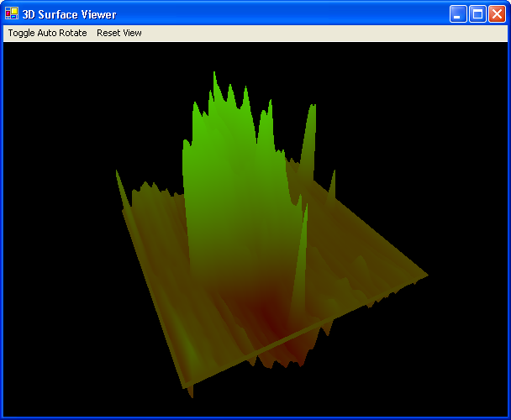
Figure 8. 3D view of convoluted surface.

To view the unconvoluted 3D surface, one may use the “No Change” filter, so the output image is identical to the input image.
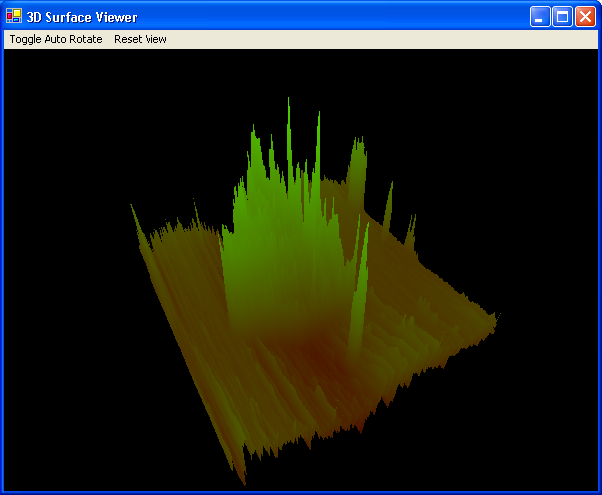
Figure 9. 3D view of unconvoluted surface.

3.2 Data Structures Employed

3.2.1 Surface Topology

The surface topology is stored within a 2 dimensional array of doubles called surfaceArray. SurfaceArrayScaled hold these values scaled to the range 0 to 1, as this is often useful to the tools. SurfaceBitmap holds a 2D false colour bitmap of the surface and is displayed in the filter output window. SurfaceFrequencyArray holds the representation of the surface in the frequency domain, calculated with the Discrete Cosine Transform.
Surfaces can be of any size, and when being using in the DCT algorithm surfaces are 8 by 8 data points in size to hold blocks of surface data.
Data structure declaration:

Bitmap surfaceBitmap = null;
public double[,] surfaceArray = null;
public double[,] surfaceArrayScaled = null;
public double[,] surfaceFrequencyArray = null;

The surface class also holds a collection of arrays for representing a 3D object which is output to the 3D window. The object vertices and normals are held by dVertexFlat and dNormalFlat respectively, and dVertexColourFlat hold vertex point colours in RGBA form, where A is an alpha value used for transparency.
IFaceIndexFlat is used for storing faces, by referring to the vertex, normal and colour arrays.
Data structure declaration:

public double[] dVertexFlat = null; //xyzxyzxyz,etc //3
public double[] dNormalFlat = null; //xyzxyzxyzetc //per point//3
public double[] dVertexColorFlat = null;//rgbargbargba etc//4
public int[] iFaceIndexFlat = null;//abcikjabcijk etc (6 elements)

3.2.2 T3DModel

T3Dmodel’s 3D data arrays, used for storing the 3D representation of tools, has a similar structure to the arrays used to store 3D surface data. T3Dmodel also has primitiveType which allows the tool designer to choose a rendering method for the tool.
Mapped directly to OpenGL’s data types, the valid types are GL_POINTS, GL_LINES, GL_LINE_STRIP, GL_LINE_LOOP, GL_TRIANGLES, GL_TRIANGLE_STRIP, GL_TRIANGLE_FAN, GL_QUADS, GL_QUAD_STRIP, and GL_POLYGON.
If the tool is to be drawn as a wireframe, the author may choose to use the GL_LINES type, and if they wish to make a selection cuboid, they may choose to use GL_QUADS. Surfaces output from filters are always drawn with triangles.
T3DModel data structure declaration:

public double[] dVertexFlat = null; //xyzxyzxyz,etc //3
public double[] dNormalFlat = null; //xyzxyzxyzetc //per point//3
public double[] dVertexColorFlat = null;//rgbargbargba etc//4
public int[] iFaceIndexFlat = null;//abcikjabcijk etc (6 elements)
public uint primitiveType=WGLAV5.GL.GL_TRIANGLES;

3.3 Data Inputs, Outputs and Formats

The application allows surfaces to be input in SDS format or a variety of image formats:
- BMP - Windows Bitmap
- EMF - Enhanced Windows metafile
- EXIF - Exchangeable Image File
- GIF - Graphics Interchange Format
- JPEG - Joint Photographic Experts Group
- PNG - W3C Portable Network Graphics
- TIFF - Tag Image File Format

HDF files [32] are output from a microscope and can be converted to SDS files through the supplementary application HDF2SDS. These SDS files can then be directly input into the application.
An SDS file is a table of values, separated by spaces. A carriage return signifies a new line. Here is an example of an SDS file:

e.g. For a 255x255 grid:
24 24 23 23 22 … (250 more values)
11 12 11 10 10 … (250 more values)
… (253 more lines.)

3.4 Use of Tools, Libraries and Existing Code
Two external libraries were used in the creation of this program. Their licences are shown in the licensing section. Their use is authorised in this application.

NCSA HDF5 (Hierarchical Data Format 5) Software Library and Utilities [32]
This is a suite of applications and a library to load from and save to a HDF file as output from a microscope. The HDF2SDS application was based on this code.

Fahey’s C# OpenGL wrapper [33]
This is a public domain wrapper for accessing OpenGL through C#. It was used to create the class for generating a display of surface and tool 3D data.

Chapter 4 - Summary

4.1 Source Code Length

This project has taken 7655 lines. 3927 of these lines are part of the WGLAV5 libraries, a wrapper around the OpenGL DLLs, so that OpenGL graphics may be shown in a program written on the .NET framework.

The classes which required the most code were as follows:

FormMain - 656 lines.
User input and output, data and image import and output, tool and filter display, user error checking, tying all modules together.

Surface – 529 lines.
Loads data from images and SDS files, performs surface convolution, conversion of surface from space domain to frequency domain through the Discrete Cosine Transform, and the creation of 2D image and 3D model output.

Classes involved with calculating the Lennard-Jones Potential [35] convolution - 793 lines.

FormLJProperties – 199 lines.
Allows selection of a tip and selection of sigma and epsilon values. Multiple units accepted.

LJPotential – 222 lines.
Class with a selection of functions related to the LJ Potential calculation. Using a separate class for these functions seemed cleaner, and alows other filters (or tools) to perform the LJ potential.

FilterPerAtomLJ – 372 lines.
Runs LJ potential convolution on surface and tip. Creates LJPotential object to perform calculations.
Creates convoluted dataset, fake colour output image and 3D model.

The remainder of the code was taken by Filters, Tools and properties windows. Filters and tools are generally small in size because they can rely on the abstract framework and helper functions available.

4.2 Extent To Which The Aims Have Been Fulfilled

4.2.1 Primary Objectives of Project

The following objectives were deemed to be essential to the project:

- Allow import from the HDF format.

Implemented. The supplementary program “HDF2SDS” will take HDF files direct from a microscope and extract the SDS files within. These SDS files can then be directly imported into the visualizer. It would be better if this converter were included within the AFM visualizer, so that inputting a HDF file would seems to be a single step process, but after considerable work to this end with limited success due to static library importing in C#, the author decided that effort be better placed elsewhere.

- Allow import of pre-generated “perfect” datasets.

Implemented. As well as import from SDS files, a user may also input surface topology in the form of a greyscale image. This can be created in an image editing program, so may take any form the user chooses.

- Display 2D representations of inputted datasets.

Implemented. Inputted surfaces are rendered in false colour and shown on the interface.

- Perform convolution on the “perfect” datasets to create distortion. This convolution would be based on data known about the tip.

Implemented. An extensible filters system has been implemented for performing this. Tip-based filters have an interface where the user may choose a tip shape.

- Display a 3D representation of real data and post-convoluted data.

Implemented. A 3D display window powered by OpenGL has been implemented and will show a 3D representation of post-convoluted data. My using the “No-effect” filter, the original perfect surface can be examined in 3D too.

- Allow user to rotate 3D representation with mouse.

Implemented. The user may manually rotate the 3D object or have it automatically rotate by selecting a menu option in the 3D window.

- Allow input of data about many different tip types, affecting the convolution effect.

Implemented. Both the DCT and LJ Potential filters allow the user to choose a tip, and then use it to perform a convolution.

4.2.2 Secondary Objectives of Project

The following objectives were deemed useful and should be implemented if time remained when primary objectives were completed:

- Allow image export from 2D and 3D displays.

Partially implemented. False colour images of convoluted surfaces can be output in various image formats (BMP, EMF, EXIF, GIF, JPEG, PNG, TIFF and WMF). Images can be output with tools overlain on the image. There is no programmed feature to output images from the 3D window. Though not ideal, a user may “screenshot” the application to save an image of the generated 3D object.

- Allow change of colour map, so that height change in 2D and 3D representations are easier to discern.

Partially implemented. False colour images of surfaces are generated, both in the input surface image box and the convoluted surface image box. There is no user feature to change the colour map used to create the false colour image, but though the filters architecture, one may choose to develop a filter that allows a user to choose the mapping of surface heights to false colours. In all the filters currently implemented, the colour map in the 3D window matches that which is the 2D convoluted surface window, but this does need to be the case in newly created filters.

- Attempt to de-convolute the real data given about the tip properties. This may be only possible to a particular level of confidence as tip shape may be irregular.

Not implemented. As mentioned in the “similar products” section, other programs implement this feature, but correct de-convolution cannot be achieved in all circumstances. This development was focused on a convolution of known surface and tip shapes, and this was not a required feature, so attention was focused elsewhere.

- Add measurement tools such as point-to-point and volume calculation.

Implemented. A selection of tools have been created to allow the user to perform analysis on convoluted surfaces. A ScanLine tool has been implemented which can be used to obtain point to point distance information (amongst other things) and a rectangle tool has been implemented allowing the user to extract the volume of a rectangular area.

- Allow comparison of real and post-convoluted “perfect” data. This could be done either visually or by performing mathematical subtraction between the surfaces.

Implemented. The input and output surfaces are displayed next to each other and a visual comparison can be performed. Some kind of arithmetic operation between the two surfaces would be a useful addition though.

- Allow image output in a variety of image formats.

Implemented. Convoluted surface images (with or without tools superimposed) can be output in the following formats:
  - BMP - Windows Bitmap
  - EMF - Enhanced Windows metafile
  - EXIF - Exchangeable Image File
  - GIF - Graphics Interchange Format
  - JPEG - Joint Photographic Experts Group
  - PNG - W3C Portable Network Graphics
  - TIFF - Tag Image File Format
  - WMF - Windows Metafile

- Allow 3D model output from the 3D display.

Not implemented. 3D model data is stored within the “Surface” object and cannot be output to a file in the current version.

- Add a feature for a program to generate its own perfect datasets, with guidance from a user.

Not implemented. But, as mentioned before, a user can create their own surfaces and tips through the use of an image editing program, and import them into the program.

- Allow choice of many material properties. This will change the convolution of the perfect data.

Implemented. The only filter implemented that is sensitive to material properties is the LJ Potential convolution filter. Information about the material’s energy well depth and hard sphere radius (atom radius), are added to the filter through the LJ Potential properties box, and the filter uses these values to generate the convoluted output.

- Allow choice between Fourier Transform based convolution, or the slower but more accurate per-atom method.

Implemented. The Fourier-Transform based convolution has been created in FilterDCT, by using the Discrete Cosine Transform. The accurate per-atom method has been implemented in FilterPerAtomLJPotental. The user may choose to use a filter through the interface, choose a tip and then run the filter.

4.2.2 Possible Expansion

The following objectives were deemed to be impossible to complete in the given time, but would be nice features to have. If the application were to be expanded, these features would be desirable:
- Add more analysis techniques. Such as cropping of dataset or cut planes.
Not implemented. However, cropping of the dataset can be easily achieved through the use of a user-created filter. Advanced analysis tools have not been created, but the architecture to quickly create and add new filters and tools has been added, which makes for a more useful application in the longer term.

- Integration with commercial hardware.
Not implemented. However output from commercial hardware in the form of HDF files can be input.

4.3 Accomplishments

- Implementation of a per-atom Lennard-Jones potential filter.
- Implementation of a Discrete Cosine Transform convolution filter.
- Implementation of the facilities to load surfaces from a wide variety of data types including SDS files, HDF and standard image formats.
- Implementation of a selection of tools for quantitative analysis of a filtered or unfiltered dataset.
- Creation of an extensible infrastructure for tools and filters which allows tools and filters to be quickly created and added.
- Implementation of a 3D window, false-colour terrain mapping, mouse rotation and graphical feedback from tools.

4.4 Conclusions and Future Work
For speed the DCT filter is applied in 8 by 8 blocks, and not over the whole surface. This gives a very large speed increase for a little inaccuracy.
When the virtual cantilever reaches the end of a block, the locations near to the edges are affected most by the inaccuracy, as the data cannot be convoluted equally around that point. A more accurate method, but still a lot faster than convoluting the whole surface, would be to recalculate the frequency response for an 8 by 8 block each time, but position the block in the centre of the point being analysed. This would slow it down the operation by about 64 times, but would be much more accurate than the unmoving block version. Convoluting the whole surface is very slow because the DCT calculation involves a running sum of all positions in the data set with all others in the data set, so a small increase in the size of the data set being processed leads to a large increase in processing time.

The per-atom Lennard-Jones Potential convolution filter is very accurate, but not quick. It would be a useful extension to this project to create a per-atom Lennard-Jones Potential convolution filter that used distributed systems to speed up processing. The current filter architecture would allow this; one just needs to write a filter.
In a large Linux computer cluster, such as a university intranet, it would be fairly simple to create a daemon on a user's space and then log in remotely as that user on every computer in the cluster, and pass a small portion of the surface and the tip shape to each computer to be processed, each daemon returning the result when complete. This distributed network code could then be applied to other filters as well.

This application was developed to assist researchers in the field of AFM where such as tool was in great demand. It grew from a simple tip-surface convolution simulator to an extensible framework of filters and tools in 2D and 3D, allowing a researcher to gain deeper information about the nature of distortion in AFM and beyond.
But the most powerful filter has not yet been written. If a system causes distortion, it can be simulated by this program.
The author looks forward to seeing what developers choose to build on this framework.

References
[1] HD5 Copyright Notice
hdf.ncsa.uiuc.edu/HDF5/doc/Copyright.html
Last accessed: 2005/ Sept /10

[2] How AFM Works
stm2.nrl.navy.mil/how-afm/how-afm.html
Last accessed: 2005/ Sept /10

[3] Eliminating Tip Effects - May 1998
Tip Convolution (Phil Williams) – SPM Digest Mailing List
spm.di.com/archives/m/1998/05/19980526.txt/3.html
Last accessed: 2005/Sept/10

[4] Massey University - Atomic Force Microscopy AFM
ite.massey.ac.nz/staff/rhaverka/AFM.htm
Last accessed: 2005/Sept/10

[5] PennState - Atomic Force Microscopy (AFM)
www.mri.psu.edu/mcl/techniques/afm.asp
Last accessed: 2005/Sept/10

[6] Yale University - Scanning Probe Microscopy
www.eng.yale.edu/reedlab/research/spm/spm.html
Last accessed: 2005/09/10

[7] The tip-sample interaction in atomic force microscopy and its implications for biological applications (1993)
David Baselt, California Institute of Technology

[8] Van der Waals force
en.wikipedia.org/wiki/Van_der_Waals_force
Last accessed: 2005/09/10

[9] H2G2 – Scanning Probe Microscopes
http://www.bbc.co.uk/dna/h2g2/A717563
Last accessed: 2005/09/10

[10] Three-Dimensional Probe and Surface Reconstruction for Atomic Force Microscopy using a Deconvolution Algorithm
A. A. Bukharaev, N. V. Berdunov, D. V. Ovchinnikov and K.M.Salikhov (1998)

[11] Tip Convolution
mechmat.caltech.edu/~kaushik/park/4-1-0.htm
Last accessed: 2005/09/10

[12] A Study Of The Surface Chemistry Of Chlorite
Gordon Ante Vrdoljak - 1994
nature.berkeley.edu/~gvrdolja/thesis.html
Last accessed: 2005/09/10

[13] Wikipedia - Convolution
en.wikipedia.org/wiki/Convolution
Last accessed: 2005/09/10

[14] Simulation of atomic force and microscope tip-sample/sample-tip reconstruction.
Peter Markiewicz and M.Cynthia Goh (2005)

[15] MIDAS Deconvolution Software
Software used to perform convolution and confidence-based deconvolution of surfaces. Similar to this application, but lacks analysis tools or 3D display.
www.weizmann.ac.il/Chemical_Research_Support/surflab/peter/wheres98/index.html
Last accessed: 2005/Aug/30

[16] Deconvo – Deconvolution program.
Attempts deconvolution and generates certainty maps of surface and tip interaction.
www.siliconmdt.com/freeware/deconvo.htm
Last accessed: 2005/Aug/30

[17] Scanning Probe Image Processor, SPIP
Modular Nano-scale image processing tool
www.imagemet.com/index.php?main=products
Last accessed: 2005/Aug/30

[18] Statscan
Height calibration program for SPM. Features 2D visualisation.
www.siliconmdt.com/freeware/statscan.htm
Last accessed: 2005/Aug/30

[19] WSxM Scanning Probe Microscopy Software
Free software for dataset visualisation. Also includes microscope control.
www.nanotec.es/genprog.htm
Last accessed: 2005/Aug/30

[20] 3D Surface View Software
3D visualisation and analysis tool
www.msmacrosystem.nl/
Last accessed: 2005/Aug/30

[21] OpenGL Home Page
Cross platform 3D Graphics API
www.opengl.org/
Last accessed: 2005/Aug/30

[22] DirectX SDK
High performance hardware interface API.
msdn.microsoft.com/directx/sdk/
Last accessed: 2005/Aug/30

[23] NVidia - Pixel Shaders
www.nvidia.com/object/feature_pixelshader.html
Last accessed: 2005/Aug/30

[24] Java3D - Libraries root page
Started by Sin Microsystems, a community developed native 3D API for Java.
j3d-core.dev.java.net/
Last accessed: 2005/Aug/30

[25] Mathworks – Makers of MATLAB
www.mathworks.com/
Last accessed: 2005/May/05

[26] VRML 97 Specification
tecfa.unige.ch/guides/vrml/vrml97/spec/
Last accessed: 2005/Aug/30

[27] C# Language Specification
msdn.microsoft.com/vcsharp/programming/language/default.aspx
Last accessed: 2005/Aug/30

[28] The Mono Project – Home Page
Sponsored by Novell. An open-source project to allow .NET applications to run on a variety of non-Windows systems.
www.mono-project.com/FAQ:_General
Last accessed: 2005/Aug/30

[29] Java
java.sun.com/
Last accessed: 2005/May/06

[30] Borland Delphi
www.borland.com/us/products/delphi/index.html
Last accessed: 2005/Aug/30

[31] Wikipedia – Radiosity
en.wikipedia.org/wiki/Radiosity
Last accessed: 2005/Sept/10

[32] NCSA HDF home page
hdf.ncsa.uiuc.edu
Last accessed: 2005/Sept/10

[33] Colin Fahey’s OpenGL Wrapper for C#
Public Domain OpenGL Wrapper for C#
www.colinfahey.com/opengl/csharp.htm
Last accessed: 2005/Sept/10

[34] Everything2 – GL4Java
Java wrapper for OpenGL by Jausoft.
www.everything2.com/index.pl?node_id=1293404
Last accessed: 2005/Sept/10

[35] Lennard-Jones Potential
polymer.bu.edu/Wasser/robert/work/node8.html
Last accessed: 2005/Sept/10

Bibliography

Papers
The Equivalence of Perpendicular Magnetic Recording and Magnetic Force Microscopy
C. D. Wright, E. W. Hill and R. Vlutters (1997)

Reciprocity in magnetic force microscopy.
C.D. Wright and E. W. Hill (1995)

AFM tip calibration using nanometer-sized structures induced by ion bean sputtering
Frank Frost, Dietmar Hirsch, Axel Shcindler and Bernd Rauschenback (2001)

Determination of the AFM tip-shape with well-known sharp-edged calibration structures: actual state and measuring results.
U. Hübner, W. Morgenroth, H.G Meyer, Th. Sulzback, B.Brendel, W. Mirandé

Polystyrene spheres on mica substrates: AFM calibration, tip parameters and scan artefacts.
M. Van Cleef, S. A. Holt, G.S. Watson and S. Myhra (1995)

Scanning Probe Microscopy
Description of STM and AFM and tip quality at the atomic level.
www.chem.qmw.ac.uk/surfaces/scc/scat7_6.htm
Last accessed: 2005/July/15

Scanning Probe Microscopy
SPM imagery and surface visualisation.
www.eng.yale.edu/reedlab/research/spm/spm.html
Last accessed: 2005/Aug/30

CNRS - IRC, Theory/Scanning Probe Microscopies (STM/AFM) Service:
Mostly about STM, but shows SPM tool structure and an image resembling the envisaged form of the 3D output window of this program.
catalyse.univ-lyon1.fr/websmcp/english/0theoriechamproche.html
Last accessed: 2005/April/27

Scanning Probe Microscopy (SPM)
“Imaging Surfaces on a Fine Scale”. Extensive site on applications, sample types, techniques and calibration.
www.mobot.org/jwcross/spm/
Last accessed: 2005/Aug/30

Deconvolution
A large selection of references on surface reconstruction and tip-reconstruction methods in AFM. Includes an interesting opinion on removing tip effects.
www.mobot.org/jwcross/spm/Deconvolution.htm
Last accessed: 2005/July/05

Veeco NanoTheatre - Polymer
Gallery of images produced from AFM
www.veeco.com/nanotheatre/nano_view.asp?nano=8&Submit=GO
Last accessed: 2005/May/05

Licensing and Copyright
All third party libraries used in this program are authorised. Their licences are shown below:

NCSA HDF Software Library [1, 32]
Portions of the code in the SDS extractor, HDF2SDS are based on code from the NCSA Hierarchical Data Format (HDF) Software Library.
Use of the source code is unrestricted as long as this copyright message remains intact.
NCSA HDF5 (Hierarchical Data Format 5) Software Library and Utilities
Copyright 1998, 1999, 2000, 2001, 2002, 2003, 2004, 2005 by the Board of
Trustees of the University of Illinois. All rights reserved. ^{[NCSA HDF]}

Fahey’s C# OpenGL wrapper [33]
“I am the sole creator of the six C# OpenGL wrapper files featured in the ZIP file. As the creator of these files, I declare their contents to be entirely in the public domain. Being in the public domain means that there is no restriction on the use of the information. It is as if the information appeared spontaneously, without an author. I put my name in the text of the files only as a casual promotion of my work; you are free to remove my name.” Colin P. Fahey

Appendix

User Guides

User Guide 1 - Applying A Filter And Using Tools To Analyse The Output.

This guide will form a generic walkthrough explaining how to apply filter to a surface, and then how to use tools to gain information from the output dataset. For this example the DCT filter will be used to show the process, but by selecting a different filter, the same steps can be followed to analyse the output from other filters.
The initial form of the application looks like this:

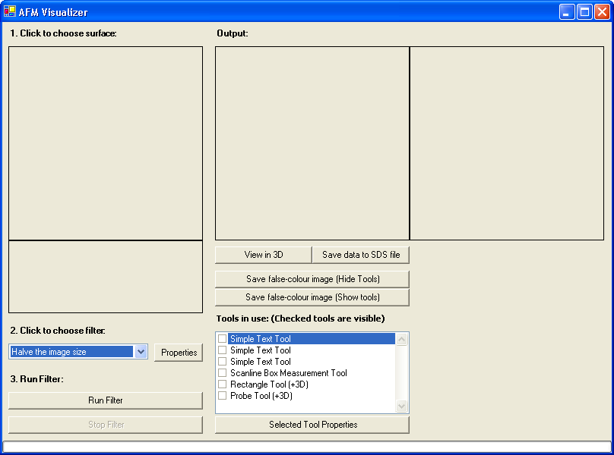
Figure 10. Initial application window.

The application is divided into input and output areas, so the original and modified surface can be compared.
First, click the input image to load your perfect surface to be filtered. This data will be a vertical displacement map.
This surface may be stored in a form directly output from a microscope such as HDF (Hierarchical Data Format) or an SDS table, or it may be in one of eight different kinds of standard image format (including Windows Bitmap, JPEG and GIF), images where the highest intensity colours are mapped to the highest features of the surface.
Once a surface has been selected, one must choose a filter to apply to it. In this case we shall choose the DCT filter, an approximation of the per-atom LJ-Potential, but any of the installed filters could be chosen.
Clicking the run filter at this point would prompt the user to select a tip, as this is required to calculate the distortion on the original surface. Clicking on the "Properties" button, we may bring up the properties window for the current filter. Here is the properties window for the DCT filter:

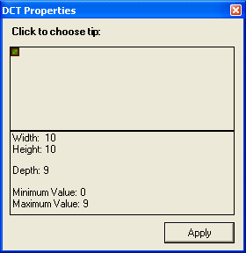
Figure 11. DCT tip selection window.

This DCT properties window allows the user to select the tip they wish to use. The tip is a displacement map, just as the surface, so a user may select from HDF, SDS tables or the image formats mentioned before to choose a tip shape. Once a tip has been chosen, this can be applied and the filter can be run. The progress bar indicates the filter's progress.

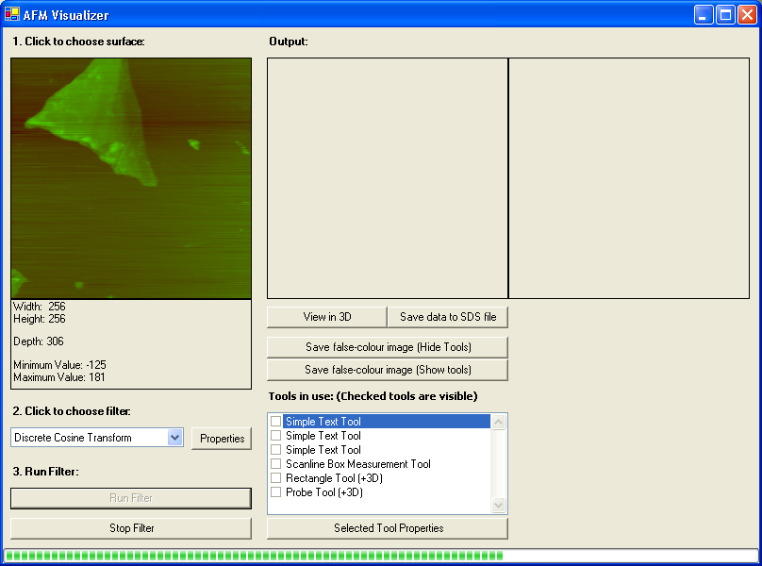
Figure 12. DCT filter processing in progress.

Once the filter has finished processing, the distorted image is shown as below.

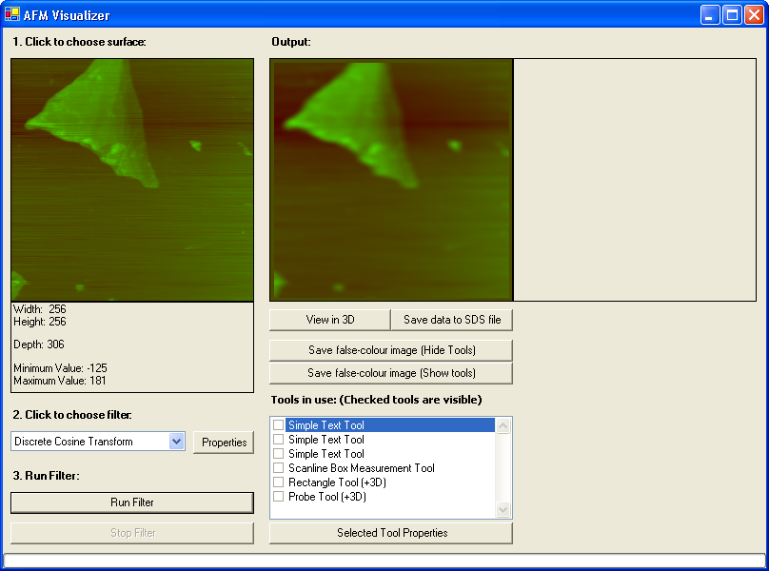
Figure 13. DCT filtered image output.

Clicking a checkbox next to a tool makes it visible. Users can select which tools they desire and apply them to the output surface. Users can add more tools to this box, including ones they have developed themselves. See the user guide below on how to create a custom tool.
This window shows an output surface with five tools applied to it. Tools create a visual effect on the output surface, and can be used to return information from the dataset. The currently selected tool is the "Probe" tool, and the information it has gathered is shown in the info pane to the right of the output surface.

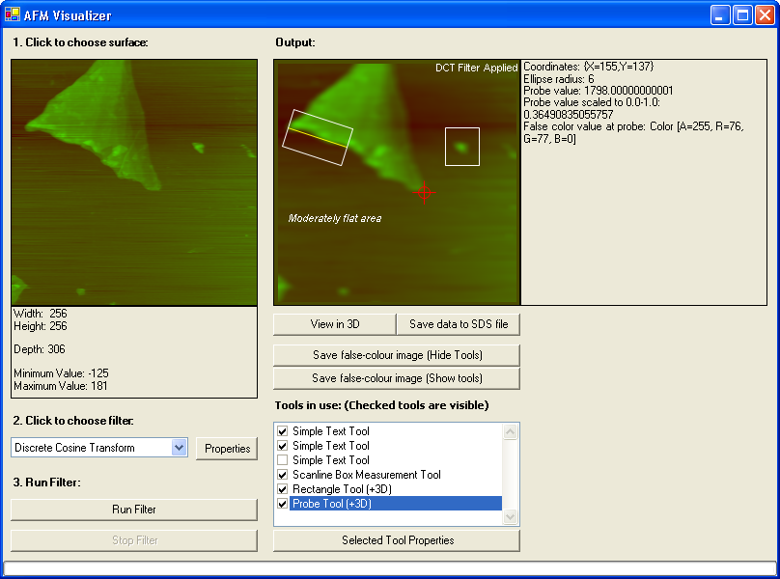
Figure 14. Selection of tools being used on convoluted image.

Two of these tools are text tools, which do not return data, but allow a user to annotate their output with useful comments. Each text tool has a properties window, accessible through the "tool properties" button which allows a user to change the font, size and colour of that label. This properties window is shown below.

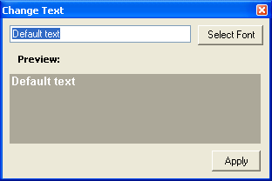
Figure 15. ToolText's text properties window.

At any point after the filter has been used, the researcher may choose to see a 3D representation of the surface by opening the 3D window. The surface within the window can be rotated with the mouse or be rotated at a slow speed automatically by clicking a menu option.

Although the usual object displayed with this window is a false colour representation of the convoluted surface, any 3D object can be rendered here. The filter is responsible for generating the 3D structure to be displayed, but there is a common function to generate a 3D false colour topology if needed.

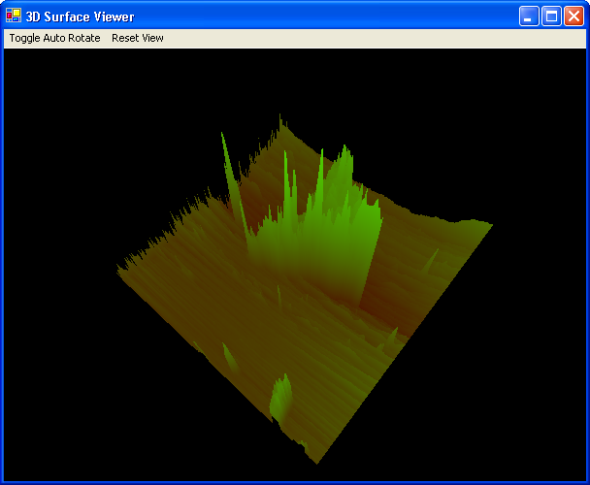
Figure 16. 3D surface without tools.

The use of tools is reflected within the 3D window also, shown here in Figure 17, is the 3D output of the “Probe” and “Rectangle” tools.

Figure 17. 3D surface with tools.

User Guide 2 - Using the Lennard-Jones Potential Filter

Atoms weakly attract each other at high distances, But as the distance between the atoms is made smaller, the atoms will eventually repel each other.
The Lennard-Jones equation takes two parameters: Epsilon, the well depth energy and Sigma, the hard sphere radius of the surface atoms. The well depth energy of a material is the highest attractive force that can exist between two atoms when they are brought closer together. This point is shown by the “well” in Figure 18, where the highest attractive force can be seen.

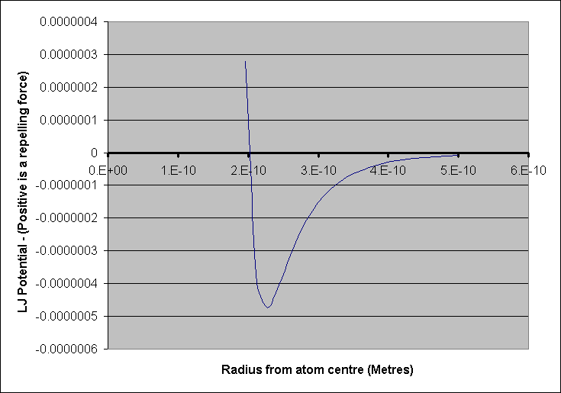
Figure 18. Graph of Lennard-Jones Potential function

When using the per-atom LJ Potential filter, one may view the properties window by clicking the “properties” button when this filter is selected. Within this window, one may choose appropriate values of epsilon and sigma, as well as real world sample measurements, which are used to calculate atom density.

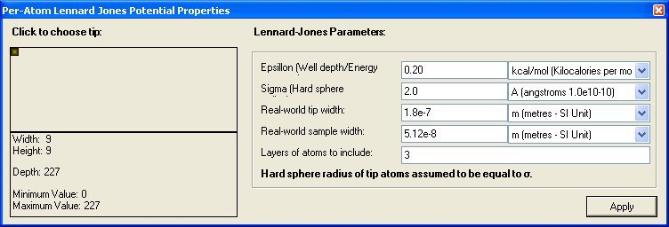
Figure 19. Properties box of Lennard Jones Potential filter.

These values are used within the Lennard-Jones potential convolution to give an accurate simulation of the output from an AFM with the tip and surface you have chosen.

User Guide 3 - Creating a User-Defined Filter.

This user guide will walk you through the process of creating a simple blurring filter. There are a variety of filters already available in the application, so one may use these as a base when implementing a new filter.
Filters need only implement the mandatory functions, getName() and apply(Surface input). getName() returns a string containing the name of the filter, and apply(Surface input) takes a surface and returns the distorted surface.
The optional functions canRun(), getWhyCannotRun() and showProperties() may be overridden as a filter may require extra data to complete its operation. For example, the per-atom Lennard-Jones Potential convolution filter requires a tip shape as well as the values of epsilon (well energy) and sigma (inter-atomic distance). If these values are not present, the filter cannot run.

canRun()
Allows filter to inform the application whether it has all the data required to run the filter. Returning false will stop the filter from being run.

getWhyCannotRun()
Returns a string explaining to the user why a filter cannot run. Such an example might be "You must choose a tip to be used on this surface."

showProperties()
Generates a properties window where users may specify extra data that is needed by the filter to perform its operation, such as a tip shape or values used in the Lennard-Jones Potential calculation. A filter object is responsible for generating its own properties window.

The apply function may be implemented in any way the user sees fit, the only requirement is that it must return a Surface, but this need not be the same size or even related to the input surface.
Two helper functions have been provided for common operations needed when generating an output surface for the filter:
Surface.recalculateBitmapFromSurfaceArray()
The surface object stores a bitmap image of the surface. This function generates a refreshed image from the data table. This disconnection allows false colour surfaces without changing the underlying data.

Surface.generate3DDataFromSurfaceArray()
The surface object can store a 3D model, this is usually a 3D representation of the surface data, but doesn't have to be. It is rendered in the 3D window. A filter may specify any kind of 3D data to be output, and does need to use this function. The 3D data is stored as standard OpenGL vertex arrays (face, vertex, normal, material), so any model can be generated from them. This function is just for convenience when a 3D terrain-like model is wanted in the 3D window.

The completed class:

public class FilterSimpleBlur:Filter
{
public override String getName(){return "Simple 5-Pixel Blur";}
public override Surface apply(Surface input)
{
Surface output = new Surface(input.width(),input.height());

int x,y;
for (y=1;y&lt;input.height()-1;y++){
for (x=1;x&lt;input.width()-1;x++) {
output.surfaceArray[x,y]=
(
input.surfaceArray[x,y-1]+
input.surfaceArray[x-1,y]+
input.surfaceArray[x,y]+
input.surfaceArray[x+1,y]+
input.surfaceArray[x,y+1]
) / 5.0;
}
}
output.recalculateBitmapFromSurfaceArray();
output.generate3DDataFromSurfaceArray();
return output;
}
}

Once the filter has been implemented, add a line to reference it in the FManager class, and the application will add it to the list of filters.

Filter[] filterArray = new Filter[] {
new FilterNoChange(),
new FilterPerAtomLJ(),
new FilterVerticalFlip(),
new FilterSimpleBlur() //Your new filter!
};

User Guide 4 - Creating a User-Defined Tool.

This user guide will lead you through the process of creating a custom tool.

All tools inherit from the Tool class; this ensures that an identical interface can be maintained with all tools. All tools must implement the following functions:

getName()
Returns a string containing the name of the tool.

applyGraphic(Image image)
Takes the current output surface image, and returns the same image with an overlay of visual feedback from the tool. For example, this function of ToolProbe returns the original surface image, with a red cross superimposed on the selected location.

getInfo()
This function returns a string of human-readable information that the tool has gathered. In ToolRectangle this contains information such as the average value in the rectangle or the location of the top-left point. If the tool does not implement this function, then the base class’s function is used and an empty string is returned.

If the developer wishes, the following functions can be overridden for additional functionality:

mouseUp()
Receive a notification when mouse button released.

mouseDown()
Receive a notification when mouse button pressed.

mouseMove()
Receive a notification when mouse position changes. In combination with mouseUp and mouseDown, this can be used to create click and drag functionality.

click()
This is a simple notification of a click.

showProperties()
This allows a tool to get information from the user. For example, the text tool's font, colour and content can be set though a properties window.

In the ToolProbe class below, the local recalc3DModel() function is called to generate a 3D model that will be rendered in the 3D window. The 3D data is stored in the tool3D object, containing structures used by OpenGL to draw a 3D object.

The completed class:

public class ToolProbe : Tool {

public ToolProbe() {
}

int ellipseRadius=6;

public override String getInfo(){

return "Coordinates: "+
(new Point(xPos,yPos).ToString())+
"\nEllipse radius: "+
ellipseRadius.ToString()+
"\nProbe value: "+
surface.surfaceArray[xPos,yPos]+
"\nProbe value scaled to 0.0-1.0: "+surface.surfaceArrayScaled[xPos,yPos]+
"\nFalse color value at probe: "+
surface.getBitmap().GetPixel(xPos,yPos).ToString();
}

public override System.Drawing.Image applyGraphic(System.Drawing.Image imgOriginal) {

Bitmap imgNew = new Bitmap(imgOriginal);

Graphics graphicImage = Graphics.FromImage( imgNew );

graphicImage.SmoothingMode = SmoothingMode.AntiAlias;

Pen probePen=new Pen(Color.Red);

graphicImage.DrawEllipse(
probePen,
new Rectangle(
xPos-ellipseRadius,
yPos-ellipseRadius,
ellipseRadius*2,
ellipseRadius*2
)
);

Point a1 = new Point(xPos, yPos+ellipseRadius*2);
Point a2 = new Point(xPos, yPos-ellipseRadius*2);
Point b1 = new Point(xPos+ellipseRadius*2, yPos);
Point b2 = new Point(xPos-ellipseRadius*2, yPos);

graphicImage.DrawLine(probePen, a1, a2);
graphicImage.DrawLine(probePen, b1, b2);

return imgNew;
}

public override string getName() {
return "Probe Tool (+3D)";
}

int xPos=0;
int yPos=0;

bool isMouseDown=false;

public override void mouseUp(object sender, System.Windows.Forms.MouseEventArgs e){isMouseDown=false;}

public override void mouseDown(object sender, System.Windows.Forms.MouseEventArgs e){isMouseDown=true;}

public override void mouseMove(object sender, System.Windows.Forms.MouseEventArgs e){
if (isMouseDown){
xPos=e.X;
yPos=e.Y;
if (xPos<0) xPos=0;
if (xPos>255) xPos=255;
if (yPos<0) yPos=0;
if (yPos>255) yPos=255;
recalc3DModel();
}
}

void recalc3DModel(){
tool3D.primitiveType=WGLAV5.GL.GL_LINES;

//Scale to -1 / 1
double xPosScaled=((xPos/255.0)*2)-1;
double yPosScaled=((yPos/255.0)*2)-1;
double zPosScaled=
(surface.surfaceArrayScaled[xPos,yPos]*2)-1;

double probeRadius=0.1;

tool3D.dVertexFlat=new double[]{
xPosScaled+probeRadius,yPosScaled,zPosScaled,
xPosScaled-probeRadius,yPosScaled,zPosScaled,
xPosScaled,yPosScaled+probeRadius,zPosScaled,
xPosScaled,yPosScaled-probeRadius,zPosScaled,
xPosScaled,yPosScaled,zPosScaled+probeRadius,
xPosScaled,yPosScaled,zPosScaled-probeRadius
};

tool3D.dNormalFlat=new double[]{
0,0,-1.0,
0,0,-1.0,
0,0,-1.0,
0,0,-1.0,
0,0,-1.0,
0,0,-1.0,
};

tool3D.dVertexColorFlat=new double[]{ 1.0,0,0,1.0, //rgba
1.0,0,0,1.0,
1.0,0,0,1.0,
1.0,0,0,1.0,
1.0,0,0,1.0,
1.0,0,0,1.0
};

tool3D.iFaceIndexFlat=new int[]{0,1,2,3,4,5}; //lines
}
}

Once the tool has been implemented, add a line to reference it in the TManager class, and the new tool will appear in the list of available tools when the application starts. As seen with ToolText, reference the new tool multiple times if you want to be able to use many instances of that tool on the output surface.

Tool[] toolArray = new Tool[] {
new ToolText(),
new ToolText(),
new ToolText(),
new ToolScanLineBox(),
new ToolRectangle(),
new ToolProbe() // Your new tool!
};

This image is based on the diagram at www.eng.yale.edu/reedlab/research/spm/afm-operation.jpg [6] (Last accessed 2005/June/08)
This could be the whole surface. In FilterDCT, the surface is subdivided and processed in 8 by 8 sections; this greatly increases the filter’s speed with negligible loss in accuracy. Good accuracy is maintained because surface points far from the tip have little influence overall Van der Waals forces.
“Common Language Infrastructure”

